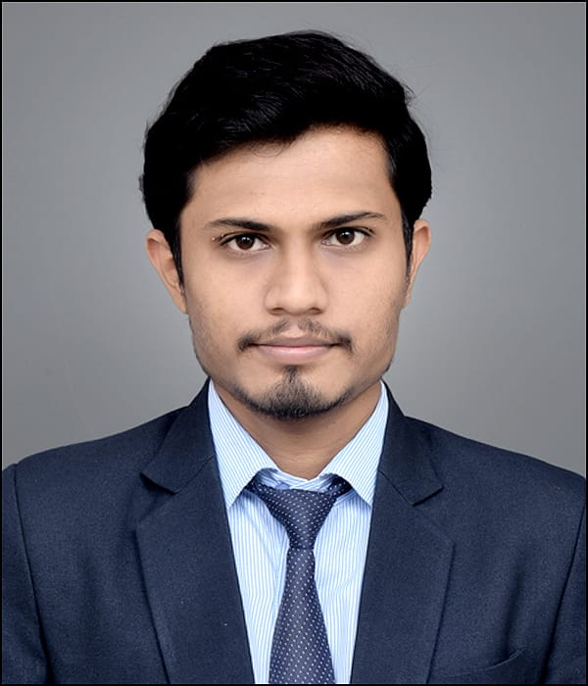

Faculty Profile

Mr. Sangam S. Nimkar

|  |  |  |
| --- | --- | --- |
| **Qualifications** | **: M. Pharm** | |
| **Specialization** | **: Pharmaceutics** | |
| **Department** | **: Pharmacy** | |
| **Designation** | **: Lecturer** | |
| **Experience** | **Industry: 0** | **Teaching: 8 Months** |
| **Publication** | **: 0** | |
| **Award/Recognition** | **: -** | |
| **Membership** | **: MSPC** | |
| **Email** | **: sangamnimkar@gmail.com** | |